
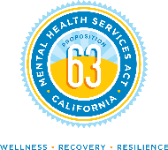
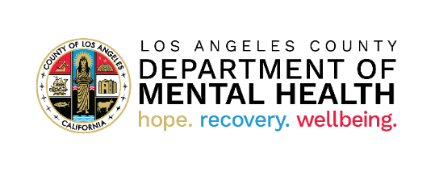
/
De Anza Elementary School
12820 Bess Ave, Baldwin Park, 91706

You’re invited to participate in a series of free, educational, and informative workshops to learn about mental health and wellness by the Los Angeles County United Mental Health Promoters Program.
9/23/2025- Immigration, Adaptation and Resilience.
10/6/2025- Grief, Loss and Resilience.
11/05/25 - Bullying Prevention.
12/18/2025- Child Abuse Prevention and Resilience
1/72026- Emotional Wellbeing and Stress.
2/4/2026- Understanding Depression and Growing
Resiliency
3/19/2026- Understanding Neurodevelopmental
4/13/2026 - Understanding the Impact of Addiction & Mental Wellness
5/4/2026 - Family Abuse Prevention and Resilience

For more information contact: Veronica Morfin

